**Positive Test Cases – Profile Page**

1.Verify that users can upload a profile photo with a valid image file format (e.g., .jpeg, .png, .gif) and size.

2.Verify that users can edit their profile information (such as name, location, bio, etc.) and the changes are saved correctly.

3.Verify that users cannot submit the form without completing required fields (such as name, email, password, etc.) and receive an appropriate error message.

4.Verify that basic information like profile name, profile image, and profile information should be displayed properly

5.Verify that each of the fields on the profile page is editable to not

6.Verify that the user is able to edit and update the profile name or not

7.Verify whether the user is able to upload and update profile images or not

8.Verify that if any validations for the profile image field or not

9.Verify that the profile image is supported by all format images or not

10. Verify that all mandatory fields should be displayed in the red “*” mark

11. Verify the File size limit - (System accepts the file accordingly or not )

12. Check that when the user tries to upload multiple photos.

13. check that all text are aligned with each other’s or not

**Negative Test Cases – Profile Page**

* 1. Verify that the user should not be able to left blank required fields
  2. Verify that the user should not be able to upload different images formats other than the expected image formats
  3. Verify that the page leaves for 3to 5 min and try to edit and save on idle pages
  4. Verify that the user should not be able to save a profile page with invalid data
  5. Verify that fields can’t be empty

**Issues – Profile Page**

* **Bug title:** no validation that mandatory fields can’t be empty

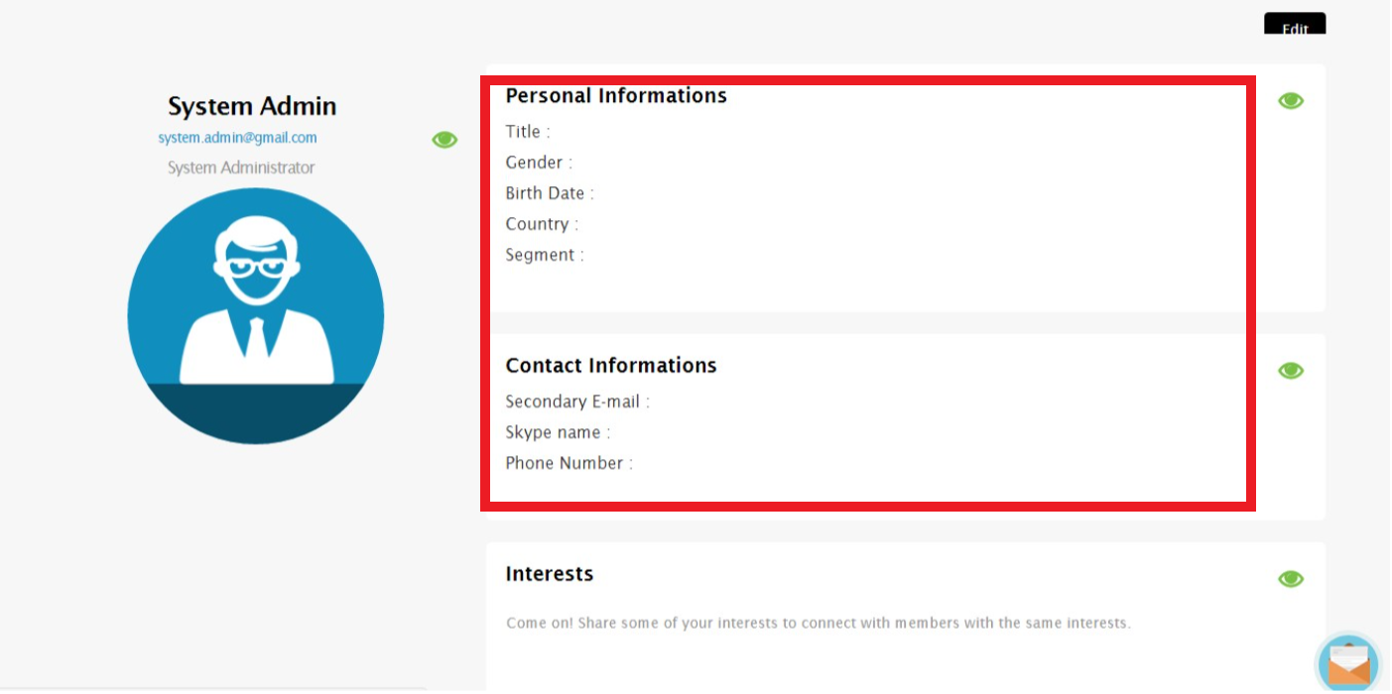

* **Severity: 2**
* **Priority: 1**
* **Steps to reproduce:**

1. Open profile page
2. Check mandatory fields in each section
3. Check that mandatory fields can’t be empty and try to save

* **Expected results:** there should be validation that mandatory fields can’t be empty
* **Actual results:** mandatory fields could be empty
* **Bug title:** no asterisks beside mandatory fields

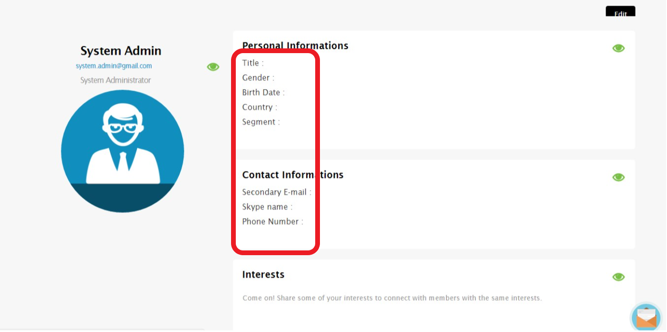

* **Severity: 2**
* **Priority: 1**
* **Steps to reproduce:**

1. Open profile page
2. Check mandatory fields in each section
3. Check that asterisk is shown beside mandatory fields

* **Expected results:** there should be asterisks beside mandatory fields
* **Actual results:** no asterisks beside mandatory fields

**--------------------------------------------------**

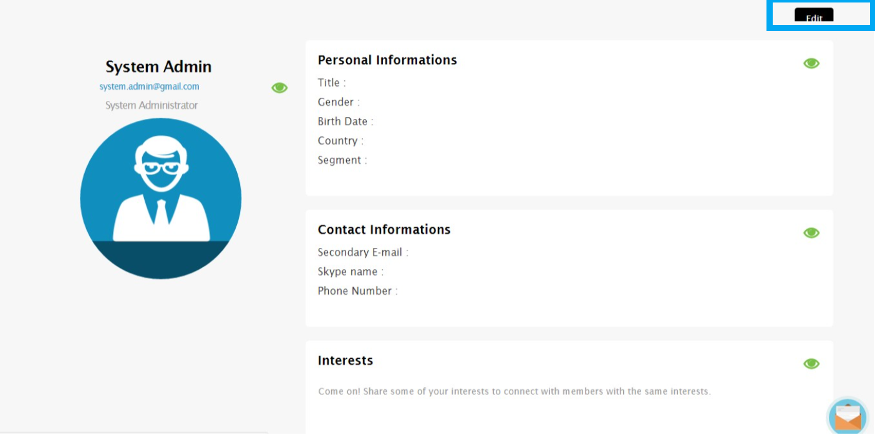

* **Bug title:** Edit button is shown cropped

**Severity: 4**

**Priority: 2**

* **Steps to reproduce:**

1. Open profile page
2. Check edit button
3. Check if it is shown completely or not

* **Expected results:** Edit button shouldn’t be cropped
* **Actual results:** Edit button is shown cropped

**-----------------------------------------------------------**

* **Bug title:** Interests section and its field can’t be shown completely

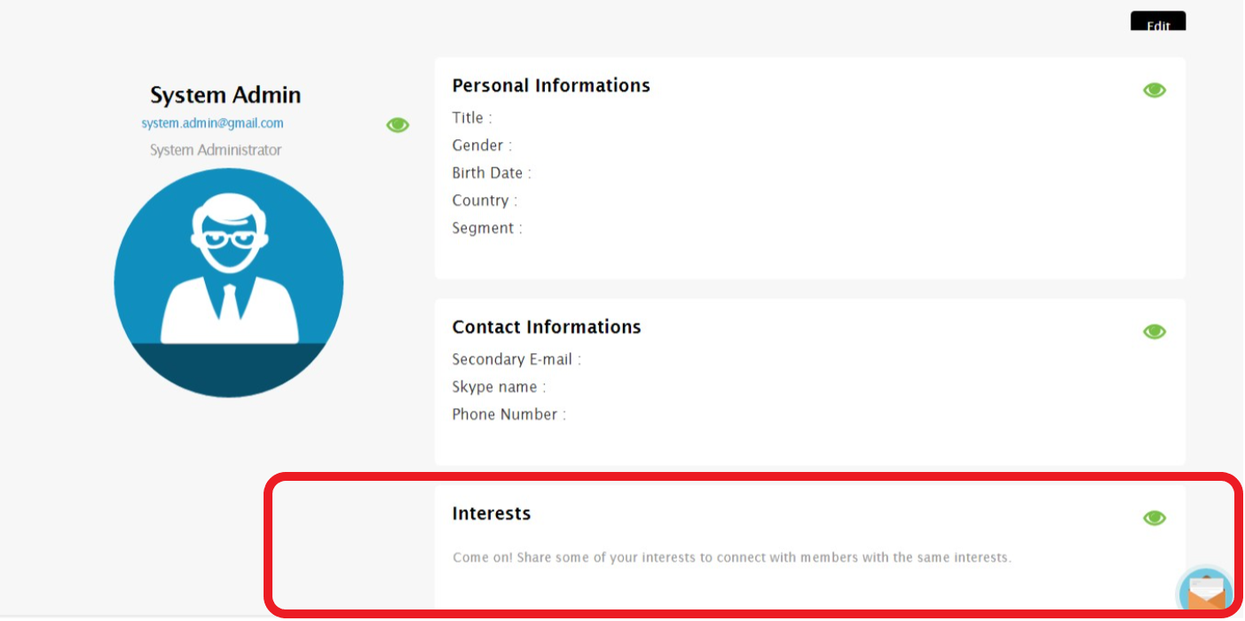

**Severity: 4**

**Priority: 3**

* **Steps to reproduce:**

1. Open profile page
2. Check interests section
3. Check if it is shown completely or not

* **Expected results:** Interests section and its field should be shown completely
* **Actual results:** Interests section and its field isn’t shown completely

**----------------------------------------------------------**

* **Bug title:** Account name text (System Admin) is not aligned with Account position info and Account mail

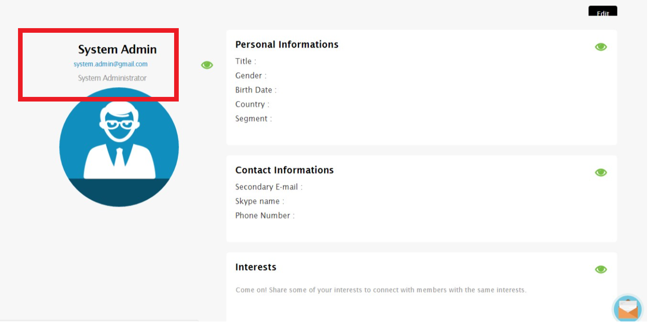

* **Severity: 4**
* **Priority: 3**
* **Steps to reproduce:**

1. Open profile page
2. Check Account name text section
3. Check if it is aligned with each other’s or not (under each other’s)

* **Expected results:** Account name text should be aligned with Account position info and Account mail
* **Actual results:** Account name text is not aligned with Account position info and Account mail

**---------------------------------------------------------**

* **Bug title:** The edit symbol should be more meaningful (would be better to be pen symbol rather than Eye symbol

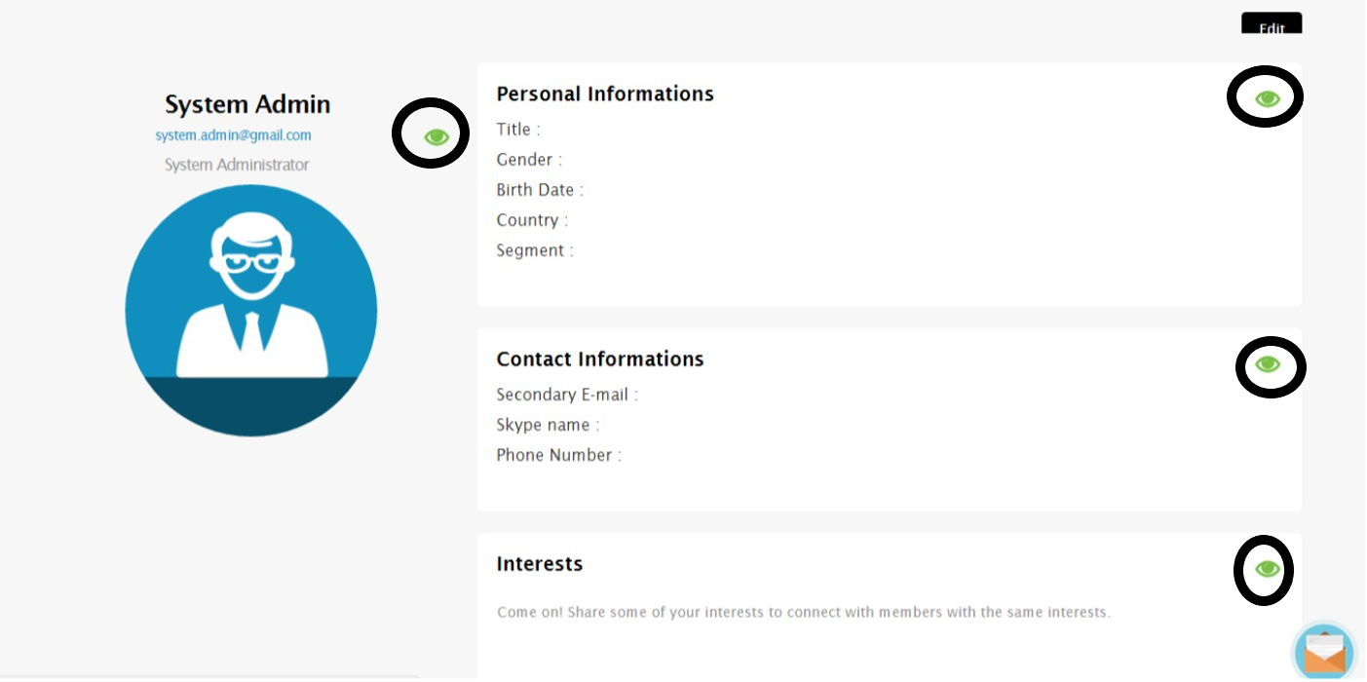

* **Severity: 4**
* **Priority: 3**
* **Steps to reproduce:**

1. Open profile page
2. Check edit symbol beside each section
3. Check if it is meaningful or not

* **Expected results:** The edit symbol should be more meaningful (would be better to be pen symbol rather than Eye symbol
* **Actual results:** the edit symbol is shown as eye symbol